Wireless Channel Model. Received signal with the noise.  
  
As we have denoted before the impulse response or else the fading coefficient of the channel is

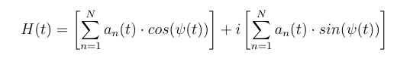   
  
The received signal in Rayleigh fading channel consists of the signal entering the channel convoluted with the fading coefficient(FCo) plus the AWGN. The relationship between the coefficient and the signal depends on if we have flat fading or selective fading.  
  
In flat fading the signal would be multiplied with the FCo instead of convoluted due to the fact that the multipath channel has only one tap cause it acts like a δ(τ).That means that the convolution reduces to a multiplication. In this case we are looking on flat-fading because we are in a narrowband scenario.  
  
The signal can be a complex baseband of the form

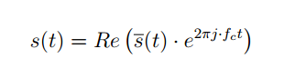

And added the complete form would look like

C:\Users\markos\AppData\Local\Microsoft\Windows\INetCache\Content.Word\3def139b3fee4c5587beb0f5dc152187.png

Y(t) is the received signal, H(t) the fading coefficient, s(t) the signal entering the channel and w(t) is the additive noise.

### <http://citeseerx.ist.psu.edu/viewdoc/download?doi=10.1.1.474.8911&rep=rep1&type=pdf> [Channel models for digital transmission - Springer](http://link.springer.com/chapter/10.1007%2F1-4020-8084-0_2) http://www.ripublication.com/irph/ijece/ijecev4n2__5.pdf